|  |  |  |  |  |
| --- | --- | --- | --- | --- |
| **National University of Computer and Emerging Sciences, Lahore Campus** | | | | |
| C:\Users\saif\AppData\Local\Microsoft\Windows\Temporary Internet Files\Content.Word\final design.jpg | **Course:** | **Data Structures Lab** | **Course Code:** |  |
|  |  | **Semester:** | **Spring 2023** |
| **Duration:** | **20 Minutes** | **Total Marks:** | **10** |
| **Paper Date:** | **11-Mar-2023** | **Weight** | **5%** |
| **Section:** | **4N1 – 4N2** | **Page(s):** | **1** |
| **Exam:** | **Quiz-1** | **Roll No:** |  |

**Question:** **:** Implement a function mergeAlternatively to merge the second linked list into the first linked list at alternate positions. Both the linked lists are singly, and their heads are passed as parameters to the function.

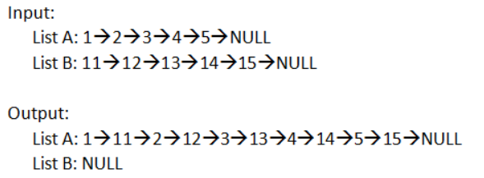  
void merge Alternatively(Node<T> *& head1, Node<T>*& head2)

{

}